Milestone 1: Create UI Policy on Incident
Description
1.Log in to the ServiceNow instance with administrative or configuration access.
2.Navigate to:
System UI → UI Policies
3.Click New to create a new UI Policy record.
4.Fill in the following details:
- Name: High Impact Control
This name clearly represents the purpose of the policy, which is to apply additional controls when an Incident has a high impact.
- Table: Incident
Specifies that the UI Policy applies to Incident records.
- Active: true
Enables the UI Policy so it is enforced on the Incident form.
5.Configure the Conditions section as follows:
- Field: Impact
- Operator: is
- Value: 1 – High
6. This condition ensures the UI Policy is triggered only when the Incident impact is set to High.
7. And Ui policy action Assignment group
8. Check mandatory
9. Set Reverse if false to true.
This ensures that when the condition is not met, any field changes applied by the policy are automatically reverted.
10. Review the configuration to ensure accuracy.
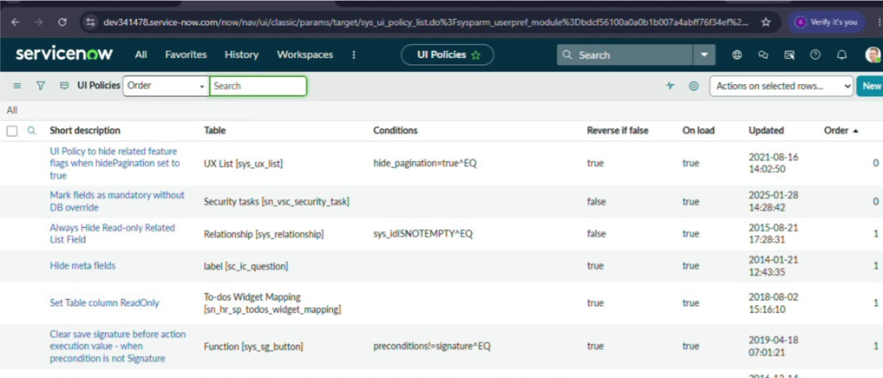
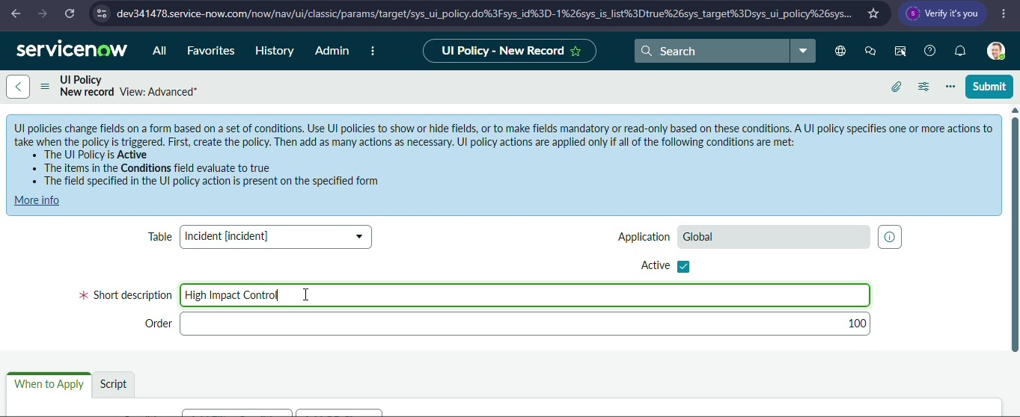

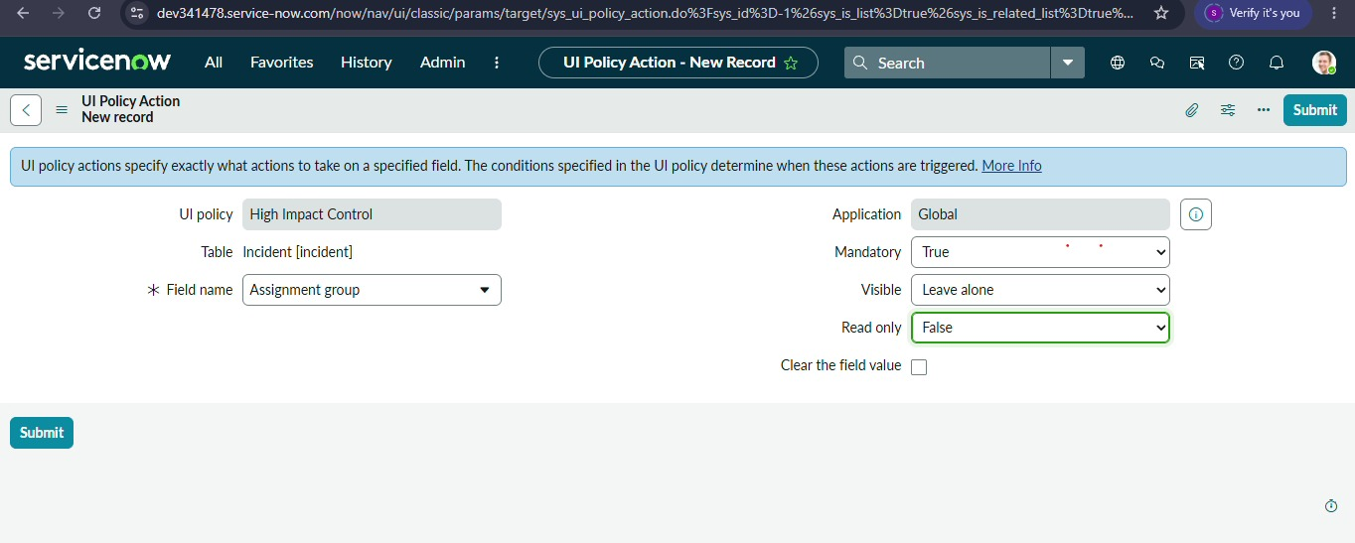

11. Click Submit to save the UI Policy.

